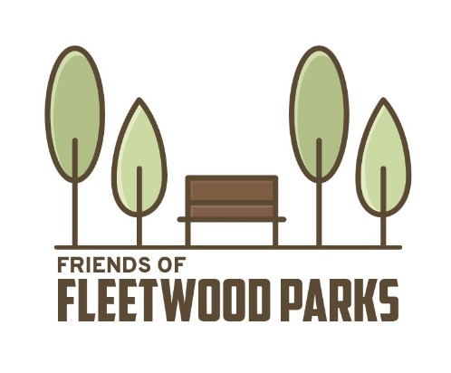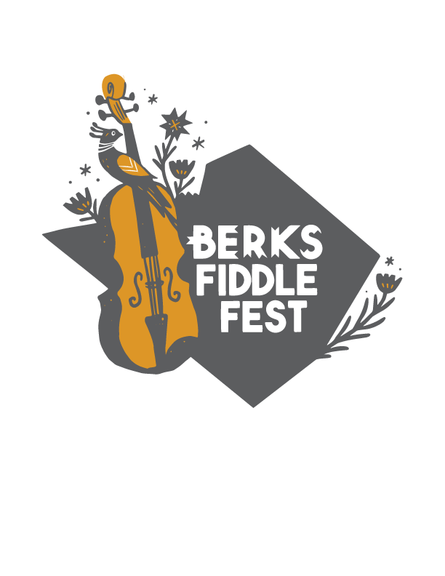

**As a friend you are entitled to:**

-The name of your choice on a 'Patrons' Board posted the day of the event

- One time announcement from stage

- Name listed in program

***Name to be used on Patrons Board: ___________________________ _________***

**Make checks payable to:**

**Friends of Fleetwood Parks**

**Mail form & payment to:**

**Eric Laub**

**916 N. Richmond street**

**Fleetwood, PA 19522**

**Sunday   
September 15th, 2024  
Fleetwood Community Park**

**Fleetwood, Pa**

**Name:____________________________________________________**

**eMail:__________________________________________________**

**Phone Number:____________________________________________**

Only $50.00

per Person, Household, Band, Non-profit or Artist !

*(No Businesses)*

**Support Music awareness in Berks County!**

**Friends of the Berks Fiddle Fest**